

DEVELOPMENT CONFIGURATION REPORT

Repository: https://github.com/C1-010/Acme-SF-D01

February 15th, 2024

Group: C1.010

García Rivero, Andrés Francisco -[andgarriv@alum.us.es](mailto:andgarriv@alum.us.es)

López Cubiles, Antonio José - [antlopcub@alum.us.es](mailto:antlopcub@alum.us.es)

Nieto Vicioso, Javier - [javnievic@alum.us.es](mailto:javnievic@alum.us.es)

Díaz Ordoñez, Pablo -  [pabdiaord@alum.us.es](mailto:%20pabdiaord@alum.us.es)

Sevillano Barea, Alejandro - [alesevbar@alum.us.es](mailto:alesevbar@alum.us.es)

Content Table

1. Executive Summary 2

2. Revision Table 2

3. Introduction 2

4. Contents 2

5. Conclusions 2

6. Bibliography 2

# 1. Executive Summary

In this document we will make clear that we have followed the guidelines to set up the development configuration and that we have it ready to work.

# 2. Revision Table

|  |  |  |
| --- | --- | --- |
| Revision number | Date | Description |
| 1 | 15/02/2024 | Initial Version |

# 3. Introduction

This Document will have a few basic explanations about how we did our set up and a few screenshots showing some of the results.

# 4. Contents

First of all, following the guidelines, we used a starter project as a base for our project. We used the Hello-World starter. We changed its name to a proper name following the guide, which is Acme-SF-D01, and then proceeded to edit de pom.xml file and create the launchers.

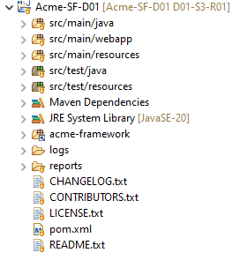

After editing the needed files and customizing the application, this was the result:

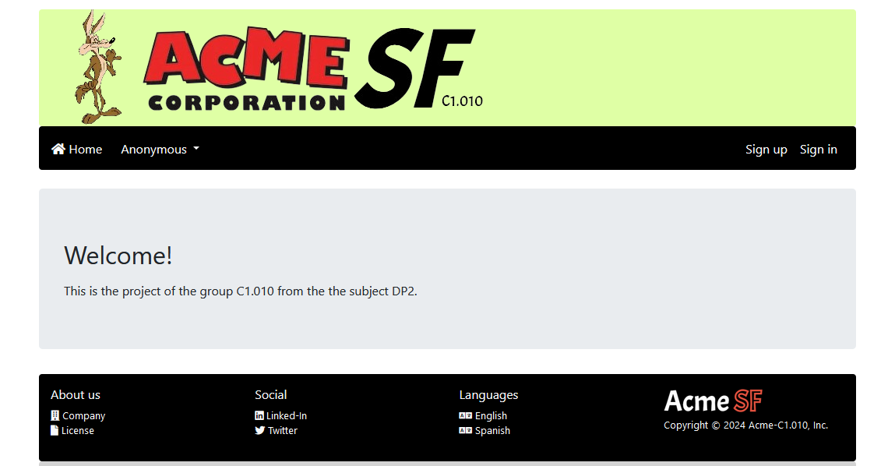

Finally, we created the databases for the project using Dbeaver and mariadb:

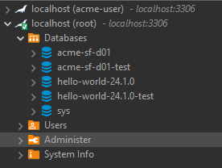

Then we created a Git repository and uploaded the project so all the members of the group could work with it. After all this steps, Acme-SF-D01 was fully ready to start working.

# 5. Conclusions

In conclusion, we have successfully set up our development configuration and we are ready to work in Acme-SF-D01.

# 6. Bibliography

Intentionally blank.